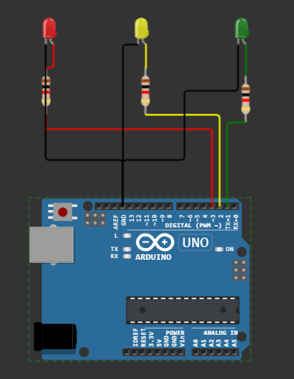

**Step 1:** **Gather the Required Components**

To build a traffic light system, you'll need the following components:

1.Arduino board (such as Arduino Uno)

2.Breadboard

3.Red, yellow, and green LEDs (one set for each traffic light)

4.Resistors (220-ohm resistors for each LED)

5.Jumper wires

**Step 2: Connect the LEDs and Resistors**

Connect the LEDs and resistors to the Arduino as follows:

Connect the longer leg (anode) of the red LED to pin 2 on the Arduino.

Connect the longer leg of the yellow LED to pin 3.

Connect the longer leg of the green LED to pin 4.

Connect the shorter leg (cathode) of each LED to a resistor.

Connect the other end of each resistor to the GND (ground) pin on the Arduino.

**Step 3: Upload the Arduino Sketch**

Open the Arduino IDE (Integrated Development Environment) on your computer and create a new sketch. Then, copy and paste the following code into the IDE:

void setup() {

pinMode(2, OUTPUT); // Red LED

pinMode(3, OUTPUT); // Yellow LED

pinMode(4, OUTPUT); // Green LED

}

void loop() {

// Red light

digitalWrite(2, HIGH);

delay(3000); // Wait for 3 seconds

// Red and yellow lights

digitalWrite(3, HIGH);

delay(1000); // Wait for 1 second

// Green light

digitalWrite(2, LOW);

digitalWrite(3, LOW);

digitalWrite(4, HIGH);

delay(3000); // Wait for 3 seconds

// Yellow light

digitalWrite(4, LOW);

digitalWrite(3, HIGH);

delay(1000); // Wait for 1 second

}

**Step 4: Connect the Arduino and Upload the Sketch**

Connect the Arduino board to your computer using a USB cable. Make sure you select the correct Arduino board and port in the Arduino IDE. Then, click the "Upload" button to upload the sketch to the Arduino.

**Step 5: Test the Traffic Light System**

Once the sketch is uploaded successfully, the Arduino will start controlling the traffic light system. The lights will cycle through the following sequence: red, red-yellow, green, yellow. You can adjust the delay times in the code to change the durations of each light.

That's it! You have successfully created a basic traffic light control system using an Arduino. You can expand on this project by adding buttons or sensors to detect traffic and adjust the light timings accordingly. Always remember to follow safety precautions when working with electronics.